**GOOD SAMARITAN HIGH SCHOOL-KIWANAGALA**

**END OF TERM II EXAMINATIONS**

**ICT FOR S3 2024**

**TIME: 1:30HRS**

**INSTRUCTIONS**

**Answer two questions**

**Answers should be written on the answer sheets provided**

**Additional question(s) will not be marked**

**Use blue or black pen**

1. In Uganda today, a lot of people are arrested due to the misuse of social media and other

Digital platforms. They post information that seem to be not appropriate to the online society. In most cases these people are youths who have just accessed smartphones and digital computing devices and at times then law finds out that those people are not aware of the actions. The information they post at times seems to be against their fellow friends in a way that discriminates, expose their confidential information and others.

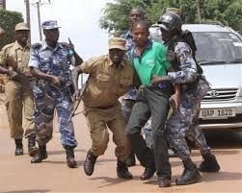

**Task**

The government of Uganda has started conducting seminars on a district level whereby the district chairperson of your area has approached you to be one of the presenters that are going to guide the youths of your region.

(i). Write a sensitization message that you will present to the youths on that day. On the theme “EFFECTIVE COMMUNICATION WHILE USING DIGITAL SYSTEMS”

1. Birongo secondary school has received some computers from the foreign aid to assist learners in their learning process through doing research and self-study. Learners and the school and the school directors where so happy since the school had abandoned teaching ict due to lack of such devices and by this the school director and the head teacher decided to allow learners offer ict at different levels.

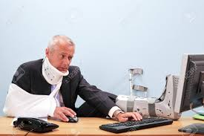After a certain period of time learner’s started experiencing health problems as a result of using these computers and among them were (backache, headache, and wrist pain Repetitive strain injuries among others)

**Task**

As an ict student who have studied ICT for 3 years, in a write-up tell these students about the causes of these health problems and how they can be avoided.

1. The librarian of your schools facing a challenge of space due to many books that are packed in his library. These books are of different types according to class and subject. These books have occupied the entire school library a seen in the picture below.

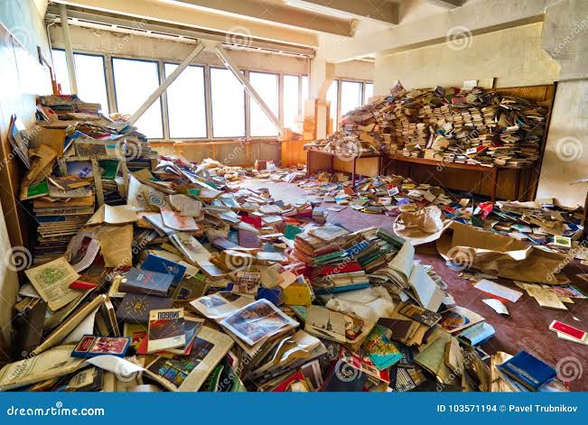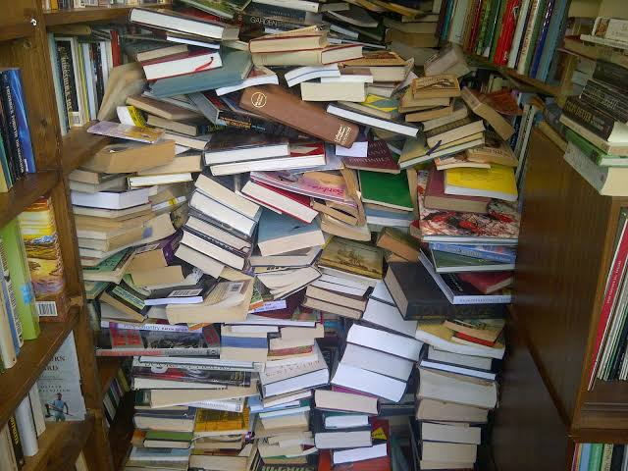

The government and the administration are willing to buy more books to enrich the library but they are facing a problem is the space.

**Task**

As an ICT learner use the ICT solution on how they can advise the school librarian on how to come-up with an ICT solution on how to have all the books without increasing the physical space.